Ruchita_Trivedi / STAT-6610 / HW-3(Chapter-3)
Wednesday, January 27, 2016
10:54 AM
1. From the Following Data website read a Project that uses maps. Explain what the project was about and what data was used. Summarize the information being presented in the maps.

URL: http://flowingdata.com/2015/05/04/map-of-most-common-race/

The map, named “Mapping the most common races”, that I choose for this question is about understanding how various
human races are distributed across the United States. This map was constructed using the data from 2013 American Community Survey 5-year estimates. Based on the plot, I was able to understand that the predominant race was White with an average of 63.3%. Next in line were 16.6% Hispanic, 12.2% Black, 4.8% Asian, 0.7% Native American or Alaskan and 0.2% Pacific Islander.
Also I can see low, medium, and high saturation levels that indicate the prevalence of a race percentage below , about the same or higher (greater than the national average plus-minus interval), or much higher than the national average (at least 50% higher).

_____________________________________________________________________________________________________________

2. From the Revolution Analytics blog find a post that uses maps. Explain what the project was about and what data was used.
Summarize the information being presented in the maps.

It’s a map of all of the R user groups listed in Microsoft's Local R User Group Directory . It's to visualize the R world as we rocket into 2016.
There will be contributed talks from Jan to March and people will be coming to Stanford from all points plotted and almost everywhere in between

From <http://blog.revolutionanalytics.com/2015/12/looking-forward-to-2016.html>

____________________________________________________________________________________________________________

3. Find a dataset of interest to you. For example, find a job description for an open position that asks for visualizations skills and pertains to a specific area of data analysis. For example, World Bank might be hiringsomeone to produce maps using World Bank Data. (Aside: Check out the Jobs Data Portal. Maybe a good source for this problem.)

o Make a plot of your data on a map using Google Charts (this is from Google Sheets in Google Docs).

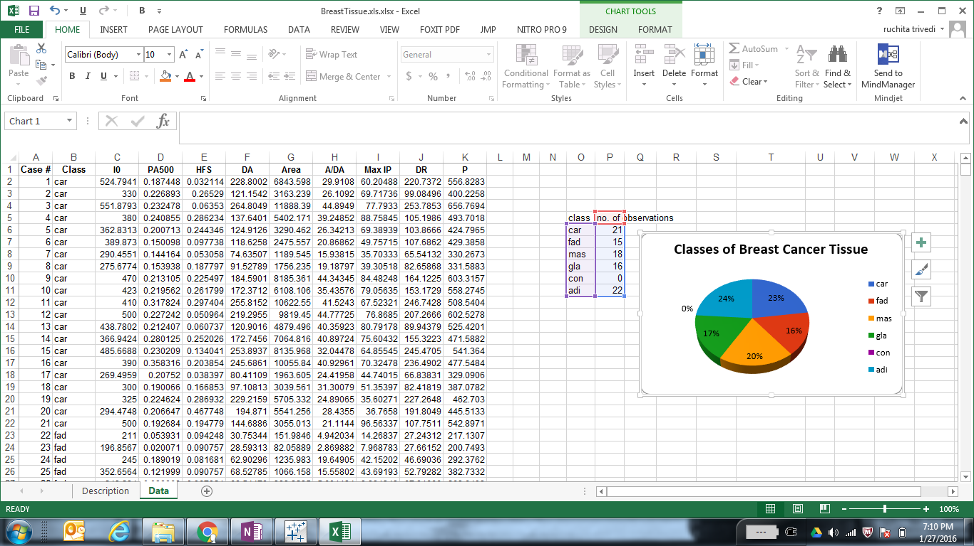

o Make the same plot of your data in tableau.

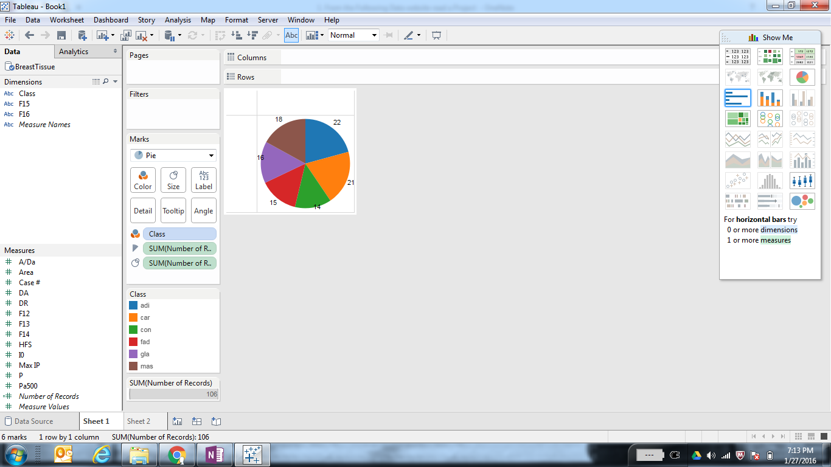

_____________________________________________________________________________________________________________

4. Install the Quandl library in R. Find an interesting dataset from Quandl and make a time series plot in R.

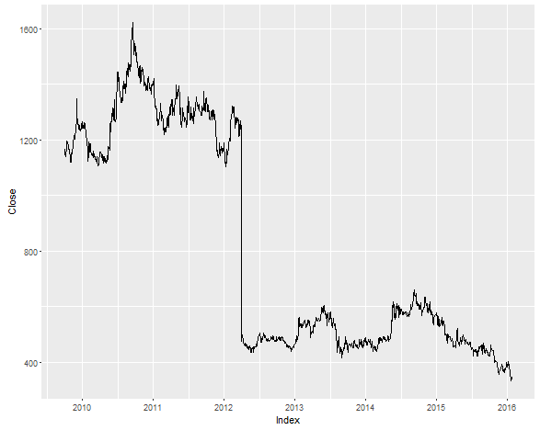

install.packages("Quandl")
library(Quandl)
#Install Quandl package from the respective GitHub repo.
install.packages("devtools")
library(devtools)
install_github('quandl/quandl-r')
library(Quandl)

#The Quandl function will allow you to download a dataset using its Quandl code.
myQuandlData <- Quandl("NSE/OIL", type="zoo")

#We can plot our time series using ggplot 2.

#Autoplot works here only because the zoo package was implicitly loaded into R with the Quandl package.
library(ggplot2)
autoplot(myQuandlData$Close) + ylab("Close")

_____________________________________________________________________________________

5. Using R run the mtcars examples from the end of the Tools presentations. Show the plots you have created in your homework document.

